To Create mkdocs according to your styling

Ensure that your project structure matches the updated documentation. The directory should look like this:

graphql

Copy code

circle_area_calculator/

├── docs/

│   └── index.md  # Your updated documentation

├── mkdocs.yml     # Your updated MkDocs configuration file

├── circle_area.py # Your Python script

└── ...            # Any other files or folders

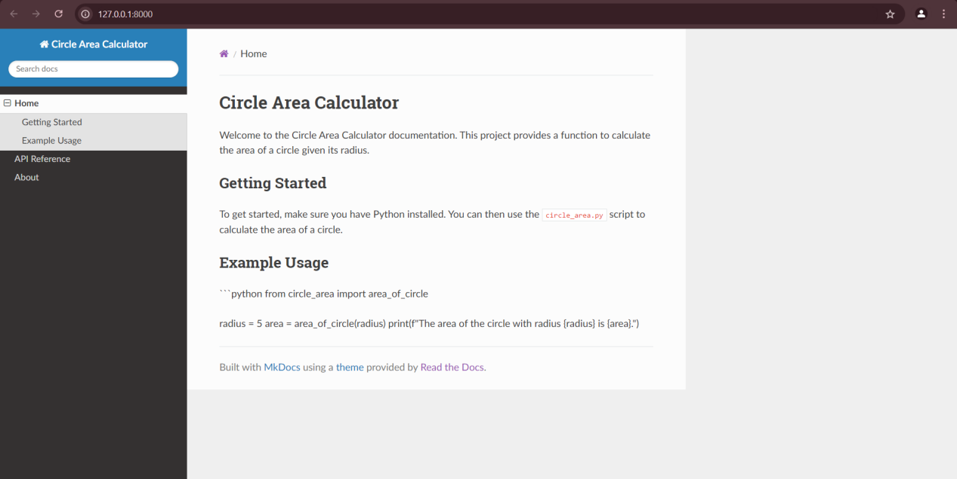

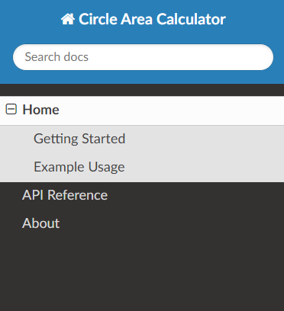File :- mkdocs.yml

site_name: Circle Area Calculator

nav:

  - Home: index.md

  - API Reference: api_reference.md

  - About: about.md

theme:

  name: readthedocs

File :- index.md

**# Circle Area Calculator**

Welcome to the Circle Area Calculator documentation. This project provides a function to calculate the area of a circle given its radius.

**## Getting Started**

To get started, make sure you have Python installed. You can then use the `circle_area.py` script to calculate the area of a circle.

**## Example Usage**

```python

from circle_area import area_of_circle

radius = 5

area = area_of_circle(radius)

print(f"The area of the circle with radius {radius} is {area}.")

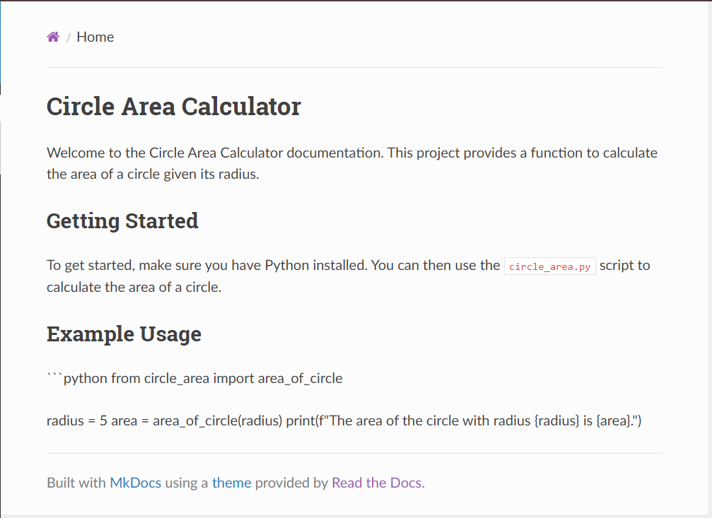

File :- circle_area.py

import math

def area_of_circle(radius):

    """

    Calculate the area of a circle.

    :param radius: Radius of the circle

    :return: Area of the circle

    """

    if radius < 0:

        raise ValueError("Radius cannot be negative.")

    return math.pi * (radius ** 2)